* Find Standard BAdI using CL_EXITHANDLER=>GET_INSTANCE

Go to the Transaction, for which we want to find the BADI, in our case we will take the example of Transaction MM02.

Search for any Material.

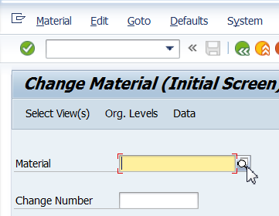

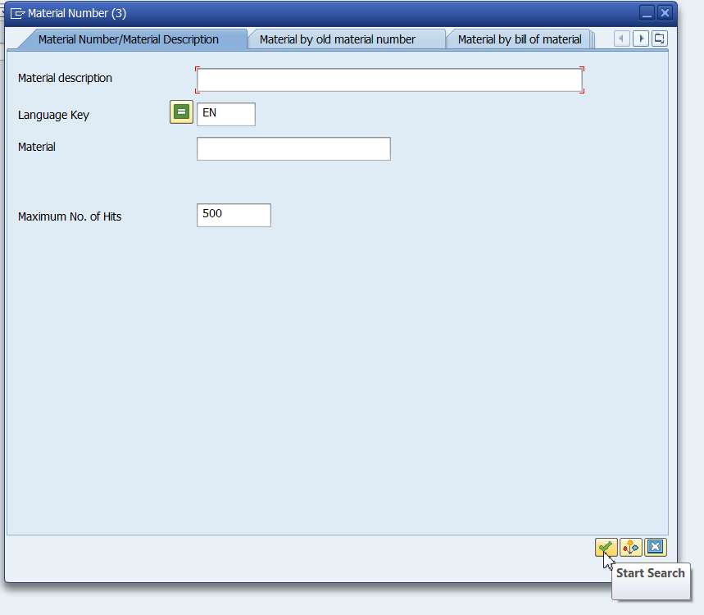

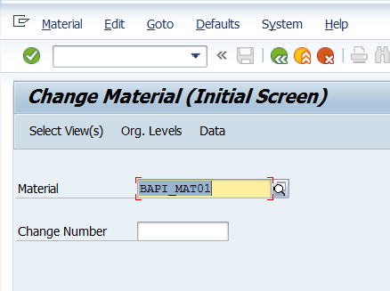

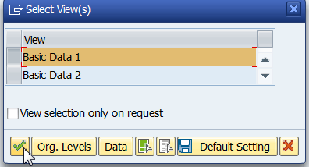

* Get the Program Name of Corresponding Transaction.

(Click on System->Status. Double Click on Program Name).

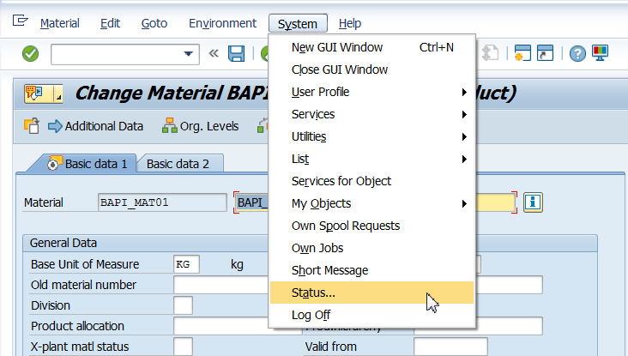

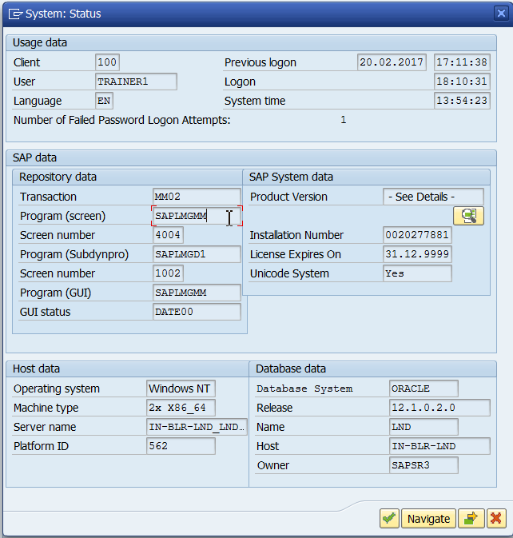

* Once inside the program search for ‘CL_EXITHANDLER=>GET_INSTANCE

Make sure the radio button “In main program” is checked.

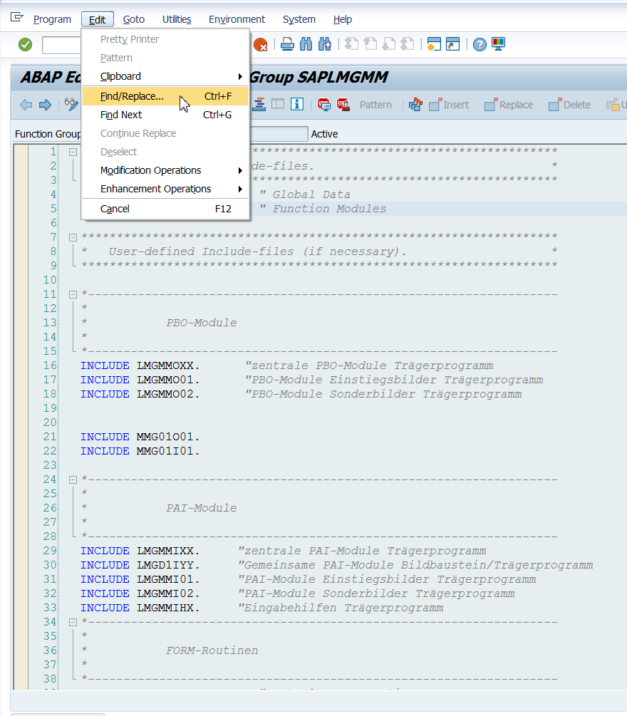

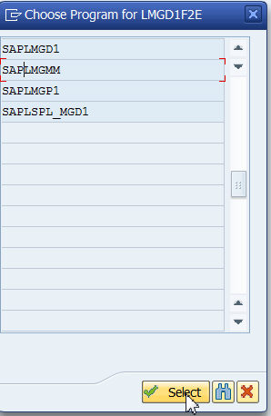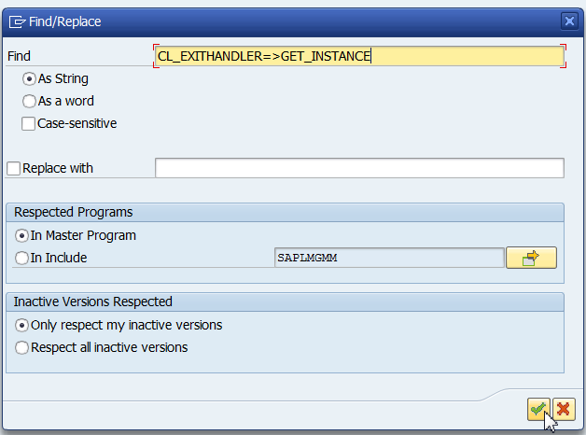

* A list of all the programs with call to the BAdI’s will be listed.
* The export parameter ‘EXIT_NAME’ for the method GET_INSTANCE of class CL_EXITHANDLER will have the user exit assigned to it.
* The changing parameter ‘INSTANCE’ will have the interface.

